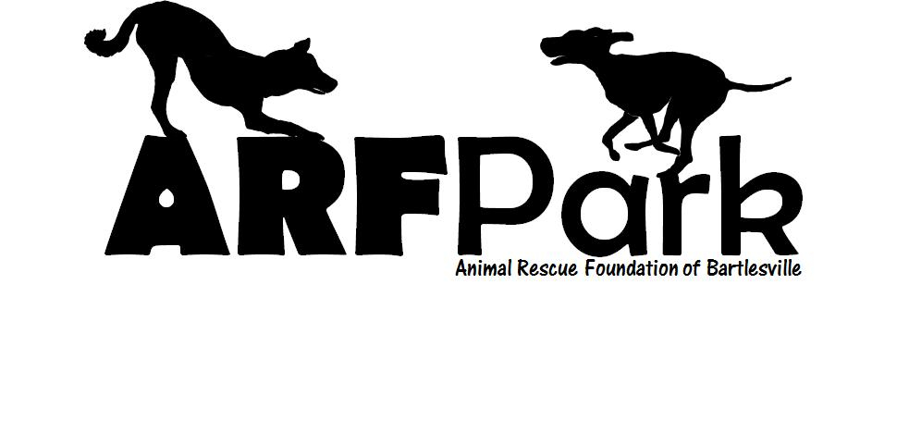
Membership Application
$50.00 annual fee per Family
"Family" membership includes any number of dogs from the same household with vaccinations documented on record. A maximum of 3 dogs allowed in park per household member.
Proof of spay/neuter, current rabies and bordetella vaccinations (kennel cough) are required to complete the membership process. If you live within the city limits of Bartlesville, it is recommended you also purchase a city license for your dog (refer to Bartlesville City Ordinance). You will need to provide this documentation to ARF with payment for the type of membership you have chosen. You will be assigned a key fob for secured entry to the park for an additional $10 deposit, which is refundable when returned to ARF. ARF is located at 399519 US 60 in Bartlesville, open from 1-4pm Mon-Fri and Sat 10am (dog side) – 4pm.day through Saturday. (All proceeds from ARF Park are used for park maintenance and to support ARF’s rescue/adoption sanctuary located adjacent to the park.)
Applicant’s Name Phone #s
Address City/State/Zip Code
Email Vet Name/Phone
Dog #1 Name Breed Age Weight
Color/Markings Sex Spayed/Neutered Yes No
Has your dog ever shown aggressive behavior towards other dogs or people? If yes, explain below:

Dog #2 Name Breed Age Weight
Color/Markings Sex Spayed/Neutered Yes No
Has your dog ever shown aggressive behavior towards other dogs or people? If yes, explain below:

Dog #3 Name Breed Age Weight
Color/Markings Sex Spayed/Neutered Yes No
Has your dog ever shown aggressive behavior towards other dogs or people? If yes, explain below:

How did you hear about ARF Park?

CONTRACT REGULATIONS
By signing this contract, you the Buyer(s), have purchased for your dog(s) a membership in ARF Park. Buyer(s) agree(s) that the annual membership fees are non-refundable unless ARF Park is no longer able to provide a substantial number of the services offered when this contract was signed, in which case Buyer(s) will receive a prorated refund.
Buyer(s) agree(s) that the membership is not transferable to another dog owner. Additional dogs owned by the Buyer(s) may be added to those named above provided the dogs are approved of by ARF park management and vaccination information is provided for documentation. Buyer(s) may cancel this contract at any time, but agrees to donate the paid membership fee. ARF Park reserves the right to deny entry to the facility or membership in the facility for any reason, and to terminate membership or expel a person and/or dog from the facility for any reason.
RELEASE AND WAIVER OF LIABILITY AND ASSUMPTION OF RISK
Animal Rescue Foundation (ARF) of Bartlesville has created ARF Park for dogs and their owners and guest to enjoy together. I understand that the use of the park and other ARF Park facilities means that I am taking certain risks of damage or injury to myself, my guest(s), my property, my dog(s) and to others in the park and associated facilities. Included in these risks are negligence on the part of ARF Park, its owners, employees, customers and guests. I realize that when dogs are around strange people and other dogs, some accident or injury may result, and that people, dogs and property might be injured or damaged.
Because I want to use and enjoy ARF Park and its associated facilities, I hereby agree to assume these risks for myself, my property and my dog(s). I agree to make an inspection of ARF Park property and continue to stay vigilant regarding the property, my property and my dog(s). I agree that it is solely my responsibility to determine whether the ARF Park property itself and any particular situation involving other members and dogs are safe for me, my property and my dog(s).
In exchange for the opportunity to use this facility, according to the Rules and Regulations, I hereby release and discharge Animal Rescue Foundation (ARF) of Bartlesville, and its owners, members and employees from any and all liability, claims, demands, causes of action, loss, damage or injury to person or property, including negligence, breach of contract, breach of any statutory duty of care, or any death and serious injury which may result while I or my guest(s) or my dog(s) are on the ARF Park premises.
I also agree to be responsible for my guest(s) and my dog(s) and for any liability caused by me, my guest(s) and my dog(s), and that I will hold harmless and indemnify Animal Rescue Foundation (ARF) of Bartlesville and its owners, members and employees from any and all liability, claims, demands, causes of action, loss, damage or injury to person or property, including any death and serious injury which may be caused by myself, my guest(s) or my dog(s) while they are on the ARF Park premises.
I agree to waive, release and forever discharge any and all claims, whether known or unknown, that I now have or may have in the future against Animal Rescue Foundation (ARF) of Bartlesville, and covenant not to sue Animal Rescue Foundation (ARF) of Bartlesville, with respect to my use of ARF Park and its associated facilities.
I am 18 years old or older and have the legal capacity to enter into a binding contract. I intend for this release to be binding upon my heirs, beneficiaries, next of kin, personal representative or executor, and assignees.
Signature: Date:
ARF PARK RULES
- Hours: Secured access from Sunrise to Sunset (Closures will be posted at the park, on ARF’s web site www.arfok.org and/or posted on Facebook.)
- All dogs must be spayed or neutered (proof required).
- Dogs must be current on vaccinations (rabies and Bordetella (kennel cough).
- Dogs are required to wear identification (id tag/rabies tag) in the park at all times even if micro-chipped.
- No more than 3 dogs per person on any one visit.
- Dogs must be leashed when entering or exiting the park.
- Dog areas (small and large) are designated by weight. Small dogs are 30 lbs and under. Large dogs are over 30 lbs. (Elderly dogs are considered to be 10+ years old and are encouraged to use the small dog area.)
- Dogs are not allowed to wear choke, pronged, pinch and spike collars while inside the park.
- Children under the age of 17 yrs old must be accompanied by a parent at all times. No children under the age of 13 are permitted in the large dog area. If the small dog area is free of guests, parents are welcome to enjoy the small dog area with children under the age of 13 with their dog(s).
- No vicious dog, as defined by the city of Bartlesville municipal code, shall be permitted. Dogs showing any signs of aggression must be removed immediately.
- Dog owners must be in park within view of their dog(s) at all times.
- NO SMOKING in the park. (Smoking area designated outside of park area.)
- Use caution when throwing balls, Frisbees or toys as this can cause aggression with some dogs.
- No food, treats, alcoholic beverages, squeaky toys or children’s toys are allowed in the dog park. (Soft drinks and water are allowed – please dispose of containers in appropriate containers.)
- PICK UP YOUR DOG’S POOP!! Owner is responsible for cleaning up dog poop Bagged waste should be disposed of properly in designated containers.
- Do not allow your dogs to dig holes. Owner will be responsible for filling any hole dug.
- Any dog left unattended within the park shall be deemed “at large” and will be eligible for city impound.
- Failure to abide by park rules will result in termination of membership with no refund.
Any concerns should be reported to the ARF at 918-766-0991 or email arfok@sbcglobal.net.
In case of emergency, call 911!
Other Considerations:
- Owners are legally responsible for any bodily injury and property damage caused by their dogs.
- First time attendees should consider coming without their dogs for the first visit and ask questions of other dog owners on how to ease the dogs stress when entering the park the first time. If you are not sure how your dog will react, try to visit when the park is less crowded and don’t force your dog to enter if you sense any aggression/tension/fear. We have the south fenced area available for problem dogs that do not play well with others. If you need to use this area, let us know and we will instruct you on how to access.
- Do not enter the double-gated entrance if someone else is already there. Wait your turn.
- Unleash your dog inside the double gated area. Some dogs feel threatened if they are leashed in the presence of unleashed dogs.
- Enter and keep walking to quickly move away from the entrance area. Move quickly away from the gate so that your dog will not feel cornered or threatened.
- If your dog becomes aggressive or disruptive, leash the dog and remove from inside the park.
- PICK UP YOUR DOG’S POOP!! Bring your own bags or use bags provided in holders along the fence.
- Keep your dog leashed at all times while outside the fenced park area. This is for your dog’s safety as well as for others safety.
- Choke, prong, pinch or spiked collars are not allowed on the dogs while inside the park. These types of collars can result in injury to its wearer, another dog or person.
- Be a responsible dog owner! If your dog is ill, contagious with any condition or has fleas/ticks, do not bring them to the park to expose other dogs. Make sure your dog is current on all vaccinations as well as flea/tick/heartworm preventative.
- If your dog becomes aggressive, put it on a leash immediately and let the dog “cool down”. It may take time for a dog to become comfortable with sharing the neutral environment with other dogs. Leave when your dog is having a good time and the dog will most likely look forward to returning for more fun.
- NO BARE FEET for the safety of you and your dog(s). Some types of worms can actually enter your body through the soles of your feet. We cannot be certain all dogs are worm-free.
- Be aware of everything going on. People are obstacles and running dogs may run into you! Be on guard for aggressive behavior as well. To break up a dog fight, do not grab for the collars! Person on each end needs to pull the tails to pull the dogs apart to avoid injury!
- For safety reasons, small dogs are not allowed in the large dog area. If you allow a small dog in with large dogs, you do so at your own risk and take full responsibility for your small dog’s injury or death that may result.
Dog Dos
DO clean up after your dog(s).
DO have a collar with proper identification and rabies tag on your dog(s) at all times.
DO watch your dog(s) at all times.
DO everything you can to avoid dog fights. If a fight occurs, pull dogs apart from the tail—never by the collar!
DO teach your dog(s) to play nicely and follow commands.
DO remove your dog(s) immediately at the first sign of aggressive behavior towards other dogs or people.
DO leash your dog when exiting the park in the double gated area.
DO spay or neuter your dog(s) as early as possible to help reduce overpopulation and risk of cancer.

Dog Don’ts
DON’T bring dogs that are not spayed or neutered into the park.
DON’T bring more than 3 dogs into the park on any one visit.
DON’T bring dogs that are sick into the park.
DON’T let your dog(s) dig holes.
DON’T leave your dogs unattended in the park at any time.
DON’T bring children under the age of 13 into the large dog area of the park.
DON’T bring people food or dog treats into the park.

